Task 1:
Problem Description:
Design a parking system for a parking lot. The parking lot has three kinds of parking spaces: big, medium, and small, with a fixed number of slots for each size.
Solution:
class ParkingSystem {

int big, medium, small;

public ParkingSystem(int big, int medium, int small) {
this.big = big;
this.medium = medium;
this.small = small;
}

public boolean addCar(int carType) {
if (carType == 1 && big > 0) {
big--;
return true;
}
else if (carType == 2 && medium > 0) {
medium--;
return true;
}
else if (carType == 3 && small > 0) {
small--;
return true;
}
return false;
}
}
Input
["ParkingSystem", "addCar", "addCar", "addCar", "addCar"]
[[1, 1, 0], [1], [2], [3], [1]]
Output
[null, true, true, false, false]

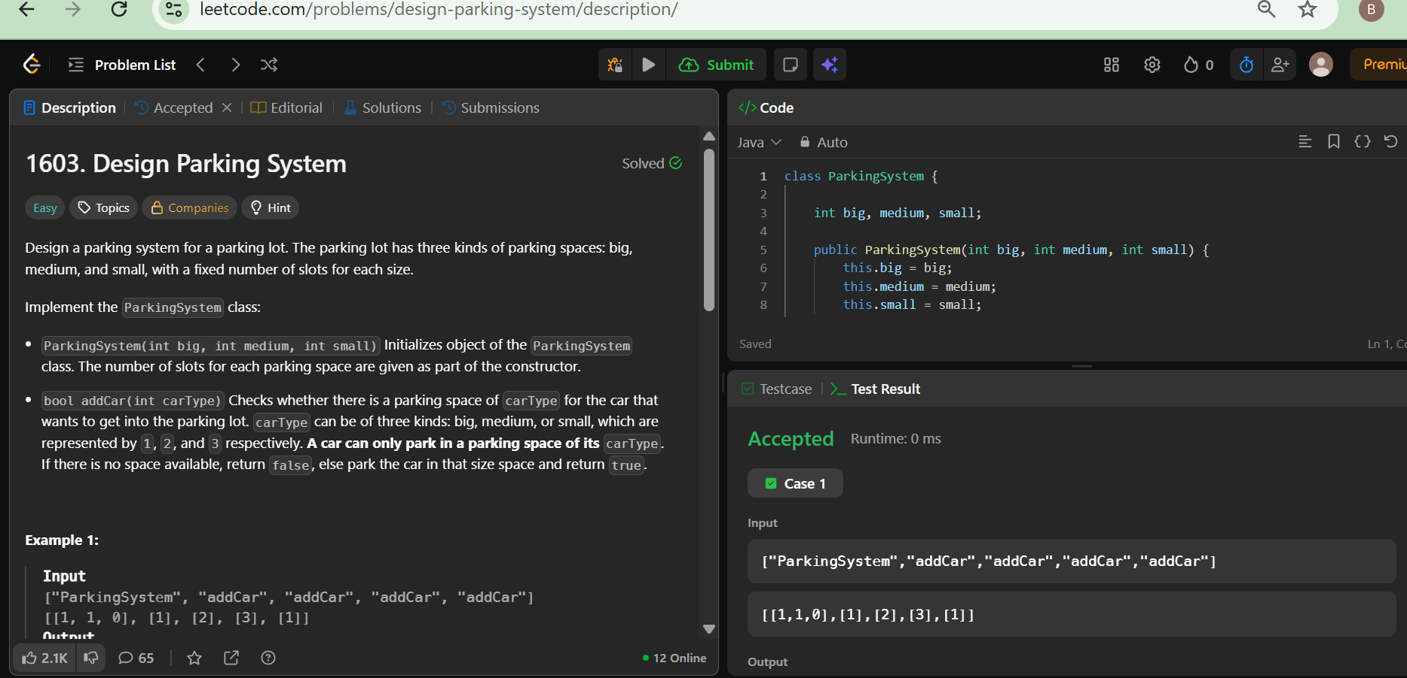

Task 2:
Problem Description:
The Java instanceof operator is used to test if the object or instance is an instanceof the specified type.
In this problem we have given you three classes in the editor:
- Student class
- Rockstar class
- Hacker class
In the main method, we populated an ArrayList with several instances of these classes. count method calculates how many instances of each type is present in the ArrayList. The code prints three integers, the number of instance of Student class, the number of instance of Rockstar class, the number of instance of Hacker class.
Solution:
if(element instanceof Student)
a++;
if(element instanceof Rockstar)
b++;
if(element instanceof Hacker)
c++;

Sample Input
5
Student
Student
Rockstar
Student
Hacker
Sample Output
3 1 1

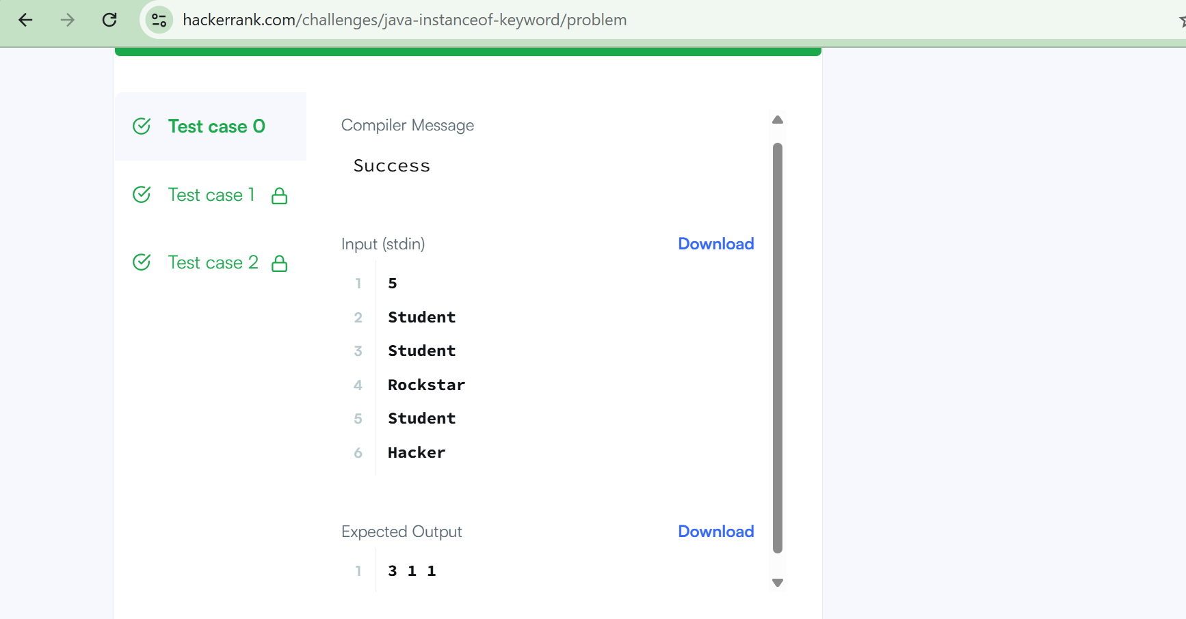
Task 3:
Problem Description:
An underground railway system is keeping track of customer travel times between different stations. They are using this data to calculate the average time it takes to travel from one station to another.
Implement the UndergroundSystem class:
- void checkIn(int id, string stationName, int t)
  - A customer with a card ID equal to id, checks in at the station stationName at time t.
  - A customer can only be checked into one place at a time.
- void checkOut(int id, string stationName, int t)
  - A customer with a card ID equal to id, checks out from the station stationName at time t.
- double getAverageTime(string startStation, string endStation)
  - Returns the average time it takes to travel from startStation to endStation.
  - The average time is computed from all the previous traveling times from startStation to endStation that happened directly, meaning a check in at startStation followed by a check out from endStation.
  - The time it takes to travel from startStation to endStation may be different from the time it takes to travel from endStation to startStation.
  - There will be at least one customer that has traveled from startStation to endStation before getAverageTime is called.

Solution:
import java.util.*;

class UndergroundSystem {

// Stores: id -> (station, time)
private Map<Integer, Pair> checkInMap;

// Stores: "start-end" -> [totalTime, count]
private Map<String, int[]> routeMap;

public UndergroundSystem() {
checkInMap = new HashMap<>();
routeMap = new HashMap<>();
}

public void checkIn(int id, String stationName, int t) {
checkInMap.put(id, new Pair(stationName, t));
}

public void checkOut(int id, String stationName, int t) {
Pair p = checkInMap.get(id);

String startStation = p.station;
int startTime = p.time;

String route = startStation + "-" + stationName;
int travelTime = t - startTime;

routeMap.putIfAbsent(route, new int[2]);
int[] data = routeMap.get(route);
data[0] += travelTime; // total time
data[1] += 1; // count
}

public double getAverageTime(String startStation, String endStation) {
String route = startStation + "-" + endStation;
int[] data = routeMap.get(route);
return (double) data[0] / data[1];
}
}

// Helper class to store check-in details
class Pair {
String station;
int time;

public Pair(String station, int time) {
this.station = station;
this.time = time;
}
}
Input
["UndergroundSystem","checkIn","checkIn","checkIn","checkOut","checkOut","checkOut","getAverageTime","getAverageTime","checkIn","getAverageTime","checkOut","getAverageTime"]
[[],[45,"Leyton",3],[32,"Paradise",8],[27,"Leyton",10],[45,"Waterloo",15],[27,"Waterloo",20],[32,"Cambridge",22],["Paradise","Cambridge"],["Leyton","Waterloo"],[10,"Leyton",24],["Leyton","Waterloo"],[10,"Waterloo",38],["Leyton","Waterloo"]]

Output
[null,null,null,null,null,null,null,14.00000,11.00000,null,11.00000,null,12.00000]

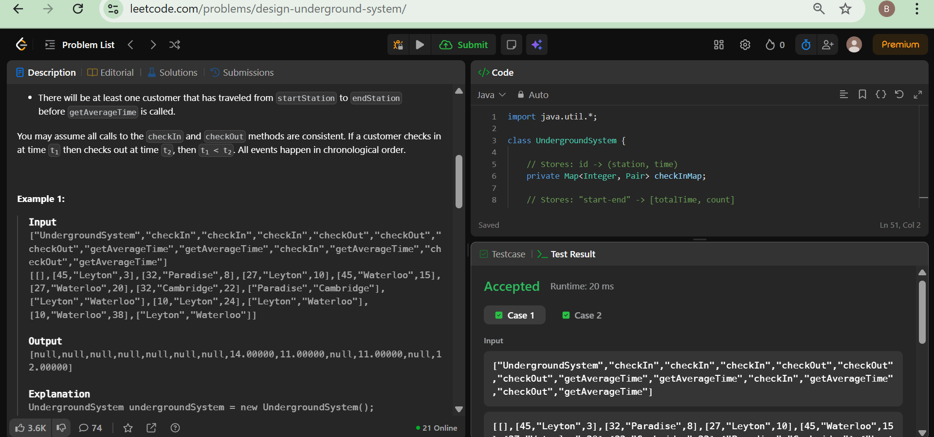

Task 4:
Problem Description:
You have a browser of one tab where you start on the homepage and you can visit another url, get back in the history number of steps or move forward in the history number of steps.
Implement the BrowserHistory class:
- BrowserHistory(string homepage) Initializes the object with the homepage of the browser.
- void visit(string url) Visits url from the current page. It clears up all the forward history.
- string back(int steps) Move steps back in history. If you can only return x steps in the history and steps > x, you will return only x steps. Return the current url after moving back in history at most steps.
- string forward(int steps) Move steps forward in history. If you can only forward x steps in the history and steps > x, you will forward only x steps. Return the current url after forwarding in history at most steps.

Solution:
import java.util.*;

class BrowserHistory {

List<String> history;
int current;

public BrowserHistory(String homepage) {
history = new ArrayList<>();
history.add(homepage);
current = 0;
}

public void visit(String url) {
// Remove forward history
while (history.size() > current + 1) {
history.remove(history.size() - 1);
}
history.add(url);
current++;
}

public String back(int steps) {
current = Math.max(0, current - steps);
return history.get(current);
}

public String forward(int steps) {
current = Math.min(history.size() - 1, current + steps);
return history.get(current);
}
}
Input:
["BrowserHistory","visit","visit","visit","back","back","forward","visit","forward","back","back"]
[["leetcode.com"],["google.com"],["facebook.com"],["youtube.com"],[1],[1],[1],["linkedin.com"],[2],[2],[7]]
Output:
[null,null,null,null,"facebook.com","google.com","facebook.com",null,"linkedin.com","google.com","leetcode.com"]

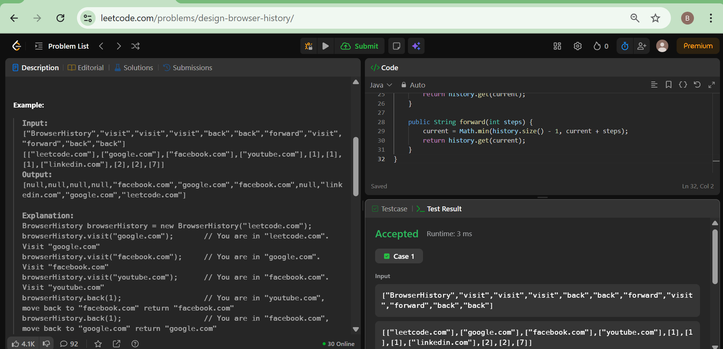
Task 5:
Problem Description:
Design a HashSet without using any built-in hash table libraries.
Implement MyHashSet class:
- void add(key) Inserts the value key into the HashSet.
- bool contains(key) Returns whether the value key exists in the HashSet or not.
- void remove(key) Removes the value key in the HashSet. If key does not exist in the HashSet, do nothing.
Solution:
class MyHashSet {

boolean[] set;

public MyHashSet() {
set = new boolean[1000001]; // range: 0 to 10^6
}

public void add(int key) {
set[key] = true;
}

public void remove(int key) {
set[key] = false;
}

public boolean contains(int key) {
return set[key];
}
}
Input
["MyHashSet", "add", "add", "contains", "contains", "add", "contains", "remove", "contains"]
[[], [1], [2], [1], [3], [2], [2], [2], [2]]
Output
[null, null, null, true, false, null, true, null, false]

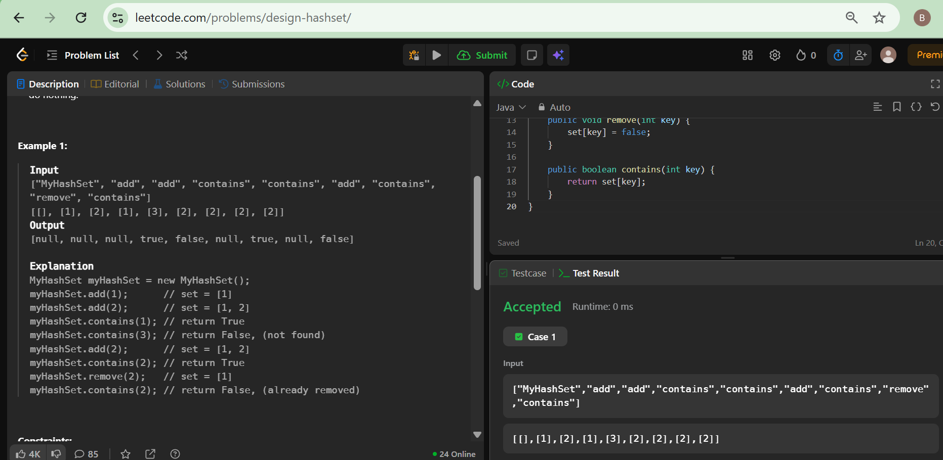
Task 6:
Problem Description:
HackerLand University has the following grading policy:
- Every student receives a in the inclusive range from to .
- Any less than is a failing grade.
Sam is a professor at the university and likes to round each student's according to these rules:
- If the difference between the and the next multiple of is less than , round up to the next multiple of .
- If the value of is less than , no rounding occurs as the result will still be a failing grade.
Examples
- round to (85 - 84 is less than 3)
- do not round (result is less than 38)
- do not round (60 - 57 is 3 or higher)
Given the initial value of for each of Sam's students, write code to automate the rounding process.
Function Description
Complete the function with the following parameter(s):
- : the grades before rounding
Returns
- : the grades after rounding
Solution:
{
List<Integer> result = new ArrayList<>();
for (int grade : grades) {
if (grade >= 38) {
int nextMultiple = ((grade / 5) + 1) * 5;
if (nextMultiple - grade < 3) {
grade = nextMultiple;
}
}
result.add(grade);
}
return result;
}
Sample Input 0
4
73
67
38
33
Sample Output 0
75
67
40
33

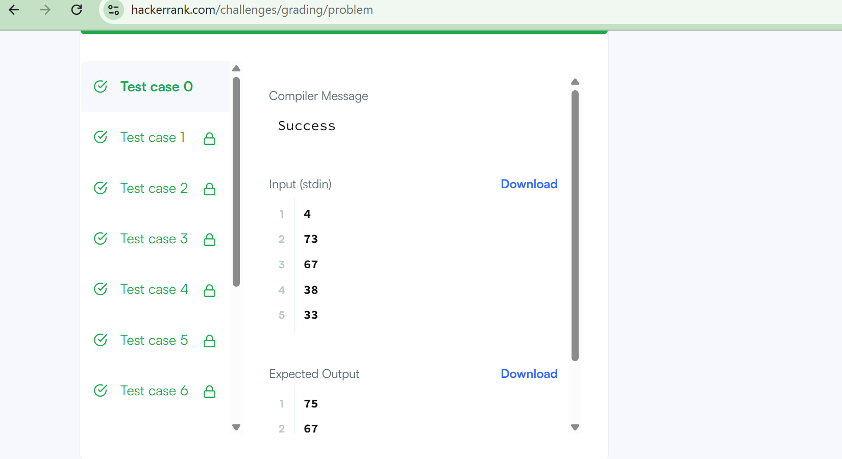

Task 7:
Problem Description:
Using inheritance, one class can acquire the properties of others. Consider the following Animal class:
class Animal{
void walk(){
System.out.println("I am walking");
}
}
This class has only one method, walk. Next, we want to create a Bird class that also has a fly method. We do this using extends keyword:
class Bird extends Animal {
void fly() {
System.out.println("I am flying");
}
}
Finally, we can create a Bird object that can both fly and walk.
public class Solution{
public static void main(String[] args){

Bird bird = new Bird();
bird.walk();
bird.fly();
}
}
The above code will print:
I am walking
I am flying
This means that a Bird object has all the properties that an Animal object has, as well as some additional unique properties.
The code above is provided for you in your editor. You must add a sing method to the Bird class, then modify the main method accordingly so that the code prints the following lines:
I am walking
I am flying
I am singing
Solution:
void sing(){
System.out.println("I am singing");
}

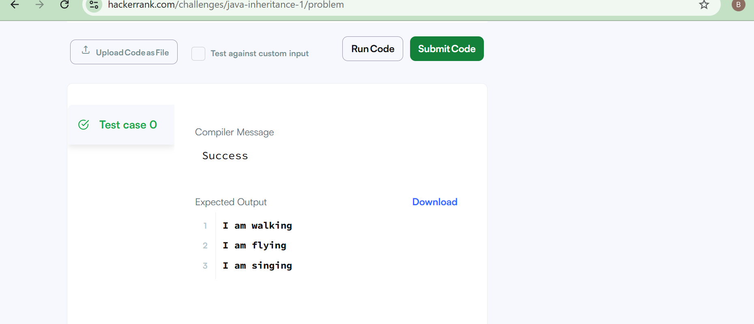

Task 8:
Problem Description:
Write the following code in your editor below:
- A class named Arithmetic with a method named add that takes integers as parameters and returns an integer denoting their sum.
- A class named Adder that inherits from a superclass named Arithmetic.
Your classes should not be be public .
Solution:
class Arithmetic {
int add(int a, int b) {
return a + b;
}
}

class Adder extends Arithmetic {
}
Sample Output
The main method in the Solution class above should print the following:
My superclass is: Arithmetic
42 13 20

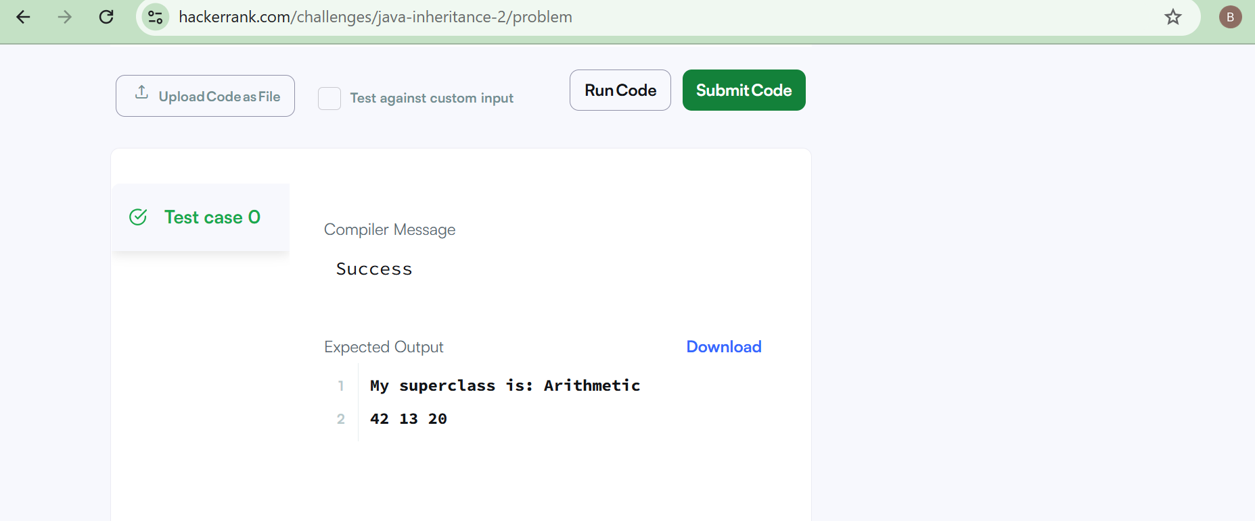

Task 9:
Problem Description:
Generic methods are a very efficient way to handle multiple datatypes using a single method. This problem will test your knowledge on Java Generic methods.
Let's say you have an integer array and a string array. You have to write a single method printArray that can print all the elements of both arrays. The method should be able to accept both integer arrays or string arrays.
Solution:
public <T> void printArray(T[] array) {
for (T element : array) {
System.out.println(element);
}
}
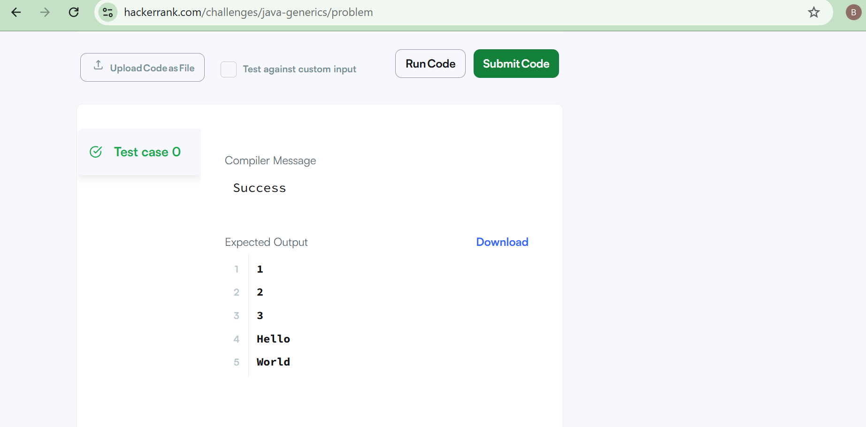
Task 10:
Problem Description:
A kingdom consists of a king, his children, his grandchildren, and so on. Every once in a while, someone in the family dies or a child is born.
The kingdom has a well-defined order of inheritance that consists of the king as the first member. Let's define the recursive function Successor(x, curOrder), which given a person x and the inheritance order so far, returns who should be the next person after x in the order of inheritance.
Successor(x, curOrder):
if x has no children or all of x's children are in curOrder:
if x is the king return null
else return Successor(x's parent, curOrder)
else return x's oldest child who's not in curOrder
For example, assume we have a kingdom that consists of the king, his children Alice and Bob (Alice is older than Bob), and finally Alice's son Jack.
- In the beginning, curOrder will be ["king"].
- Calling Successor(king, curOrder) will return Alice, so we append to curOrder to get ["king", "Alice"].
- Calling Successor(Alice, curOrder) will return Jack, so we append to curOrder to get ["king", "Alice", "Jack"].
- Calling Successor(Jack, curOrder) will return Bob, so we append to curOrder to get ["king", "Alice", "Jack", "Bob"].
- Calling Successor(Bob, curOrder) will return null. Thus the order of inheritance will be ["king", "Alice", "Jack", "Bob"].
Using the above function, we can always obtain a unique order of inheritance.
Implement the ThroneInheritance class:
- ThroneInheritance(string kingName) Initializes an object of the ThroneInheritance class. The name of the king is given as part of the constructor.
- void birth(string parentName, string childName) Indicates that parentName gave birth to childName.
- void death(string name) Indicates the death of name. The death of the person doesn't affect the Successor function nor the current inheritance order. You can treat it as just marking the person as dead.
- string[] getInheritanceOrder() Returns a list representing the current order of inheritance excluding dead people.

Solution:
import java.util.*;

class ThroneInheritance {

Map<String, List<String>> family;
Set<String> dead;
String king;

public ThroneInheritance(String kingName) {
family = new HashMap<>();
dead = new HashSet<>();
king = kingName;
family.put(kingName, new ArrayList<>());
}

public void birth(String parentName, String childName) {
family.putIfAbsent(parentName, new ArrayList<>());
family.get(parentName).add(childName);
family.put(childName, new ArrayList<>());
}

public void death(String name) {
dead.add(name);
}

public List<String> getInheritanceOrder() {
List<String> result = new ArrayList<>();
dfs(king, result);
return result;
}

private void dfs(String person, List<String> result) {
if (!dead.contains(person)) {
result.add(person);
}

for (String child : family.get(person)) {
dfs(child, result);
}
}
}
Input
["ThroneInheritance", "birth", "birth", "birth", "birth", "birth", "birth", "getInheritanceOrder", "death", "getInheritanceOrder"]
[["king"], ["king", "andy"], ["king", "bob"], ["king", "catherine"], ["andy", "matthew"], ["bob", "alex"], ["bob", "asha"], [null], ["bob"], [null]]
Output
[null, null, null, null, null, null, null, ["king", "andy", "matthew", "bob", "alex", "asha", "catherine"], null, ["king", "andy", "matthew", "alex", "asha", "catherine"]]

